
SEDIMENT SAMPLING

Sea Surveyor owns and operates two (2) vibratory corers (Vibracores) capable of collecting continuous core samples of 5’, 10’, 15’, 20’, or 30’ lengths. The sediment cores are contained within clear, 3.5”-diameter, chemically-inert liners that can be cut into client-specified lengths, capped for transport, labeled for identification, and stored on ice until delivered to the laboratory. In addition to our vibracores, we use a gravity corer for collecting short (1’-5’) cores in unconsolidated sediments, and grab samplers for collecting surficial sediments.

The ALPINE vibracorer is the largest and most powerful vibratory corer ever built. This vibracore is capable of penetrating 20’, 30’, or 40’ into the seafloor to collect a continuous stratigraphic sequence of soils material. A quadropod stand allows the ALPINE vibracore to be set on the seafloor and operate without the need to anchor the support vessel. A vessel with 20-ton crane is typically needed to extract the core barrel from the seafloor.  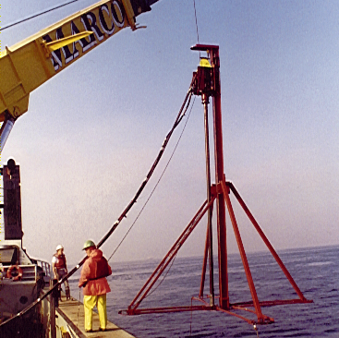  Example Project:  San Diego Beach Renourishment |  | Our MINI-VIBRACORER was custom-designed for collecting 5’-15’ sediment cores from small, shallow-draft vessels. The Mini-Vibracore can be easily transported and assembled for short-term projects at remote sites. The Mini-Vibracore has a large, flat base that enables it to be set on the seafloor and operated without anchoring the vessel. A 5-ton crane is usually used to deploy the Mini-Vibracore.  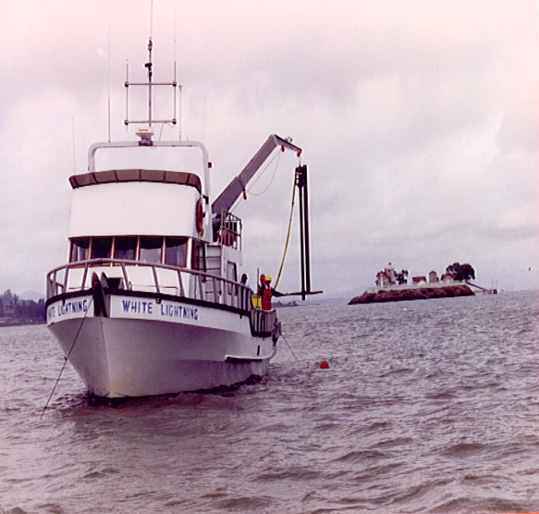  Example Project:  Morro Bay Wetlands Sampling |  | A GRAVITY CORER is similar to a dart. When released from the support vessel, the gravity corer plunges through the water and penetrates into the unconsolidated sediments on the seafloor. Capable of collecting 1’-5’ sediment cores, our gravity corer is a quick and cheap method for sampling surficial soils.  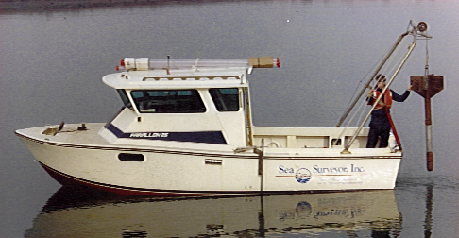  A PENETROMETER displays the rate of penetration of the vibracore into the seafloor. Penetrometer data is used to determine the core’s depth-of-refusal, and can be plotted as a penetration profile to evaluate soil consistency.  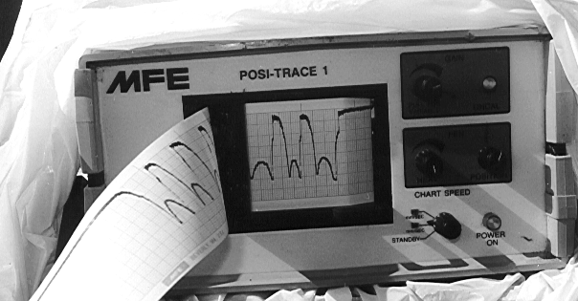
960-C Grant Street, Benicia CA 94510
(707) 746-1853 info@seasurveyor.com

