OCEANOGRAPHIC MONITORING
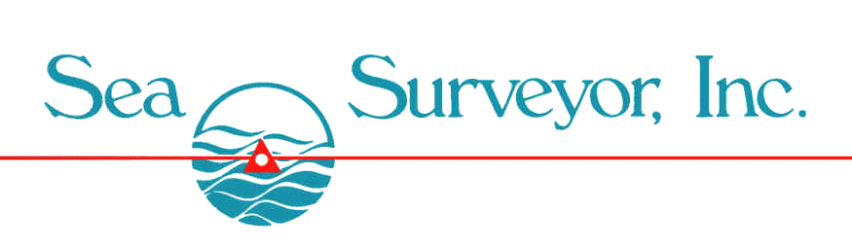

Sea Surveyor owns and operates numerous types of sophisticated oceanographic sensors that monitor tides, waves current speed and direction, and diffusion/dispersion. Typical applications include:
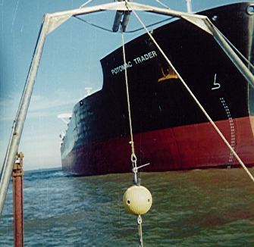
CURRENT MONITORING:
- InterOcean S-4 meters are used to measure current velocity and direction.
- Seafloor-mounted ADCP meters measure current speed/direction for entire water column.
- Computerized processing and plotting of current speedand direction statistics.

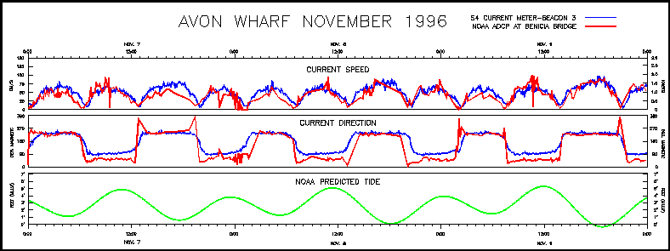
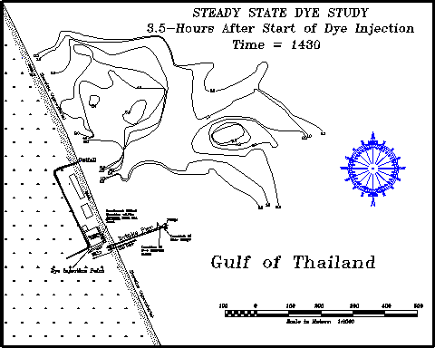

Results from Dye Study in Southeast Thailand Wave/Tide Gauge Time-Series Plot for Tides and Current Speed/Direction
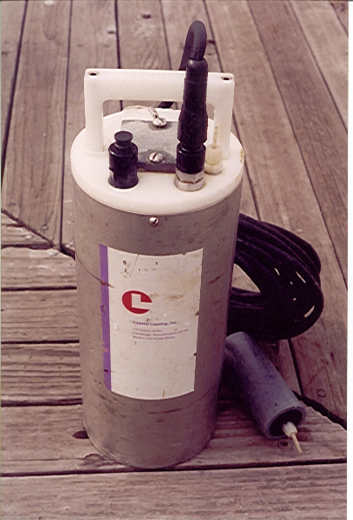
960-C Grant Street, Benicia CA 94510
(707) 746-1853 info@seasurveyor.com
DYE DIFFUSION STUDIES:
- Identify water circulation patterns.
- Measure turbulent diffusion.
- Identify optimal outfall site location.
WAVE AND TIDE MONITORING:
- Continuous deployments from 1-day to 1-year.
- Subsurface pressure-sensors measure water surface elevation to mm accuracy.

- Wave height, wave length, wave period, and wave direction (optional)

Example Oceanographic Monitoring Investigations:
- 2002: 3-Month Deployment of ADCP current profilers and Thermister Chains at 3 Offshore Locations near Sewage Outfall Diffuser for Orange County Sanitation Dept.
- 1996: Current/Tide Monitoring near Oil Tanker Moorings in San Francisco Bay.
- 1991: Steady State Dye Studies and Patch Dye Tests in the Gulf of Thailand for Engineering Design of Aquaculture Ponds.
- 1989: 2-Year Oceanographic Monitoring Program for San Diego Ocean Outfall Design.

