MARINE VEGETATION SURVEYS
Sea Surveyor has been conducting marine vegetation surveys for environmental companies and regulatory agencies since the early 1990's. With our extensive experience and new high-resolution sonar equipment, Sea Surveyor can produce highly-accurate charts showing the spatial distribution and density of different species of marine vegetation, as well as water depth, sediment type, and size/shape of reefs.
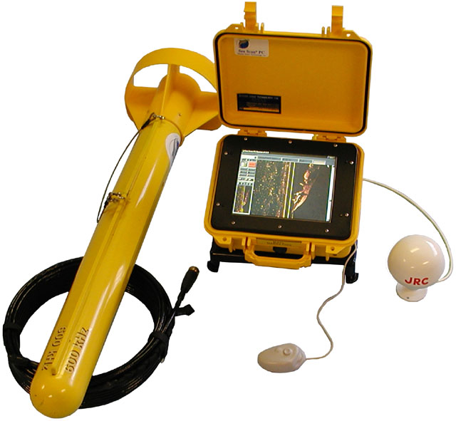

Sea Surveyor locates and delineates reefs and areas of marine vegetation using a high-frequency side-scan sonar and a survey-grade fathometer. After the sonar data is interpreted aboard the survey boat, a detailed chart is produced that allow divers to immediately confirm the vegetation type, vegetation density, and reef height.
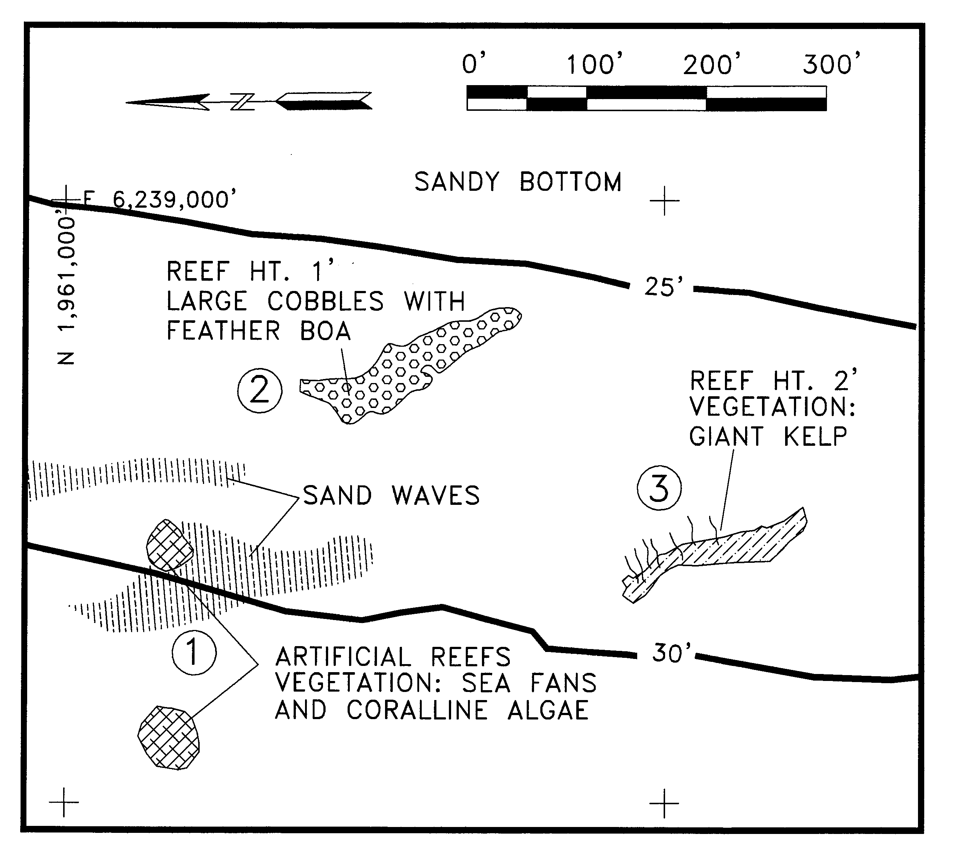
REPRESENTATIVE PROJECTS

2000: Side-scan sonar surveys along the San Diego County coastline to locate reefs and chart the
distribution and density of marine vegetation. Client: San Diego Association of Governments.

1999: Diver surveys at US Coast Guard Station, San Diego for pre-dredge assessment of marine
vegetation. Client: United States Coast Guard, Civil Engineering Unit.

1996: Side-scan sonar and fathometer survey of the Port of Richmond Terminal 4 in San Francisco
Bay to identify and quantify areas with marine vegetation. Client: Wickland Oil Company.

1994: Sonar survey in Richmond Harbor to map the spatial distribution and density of eelgrass beds
in support of Channel Deepening Project. Client: Corps of Engineers, San Francisco District.
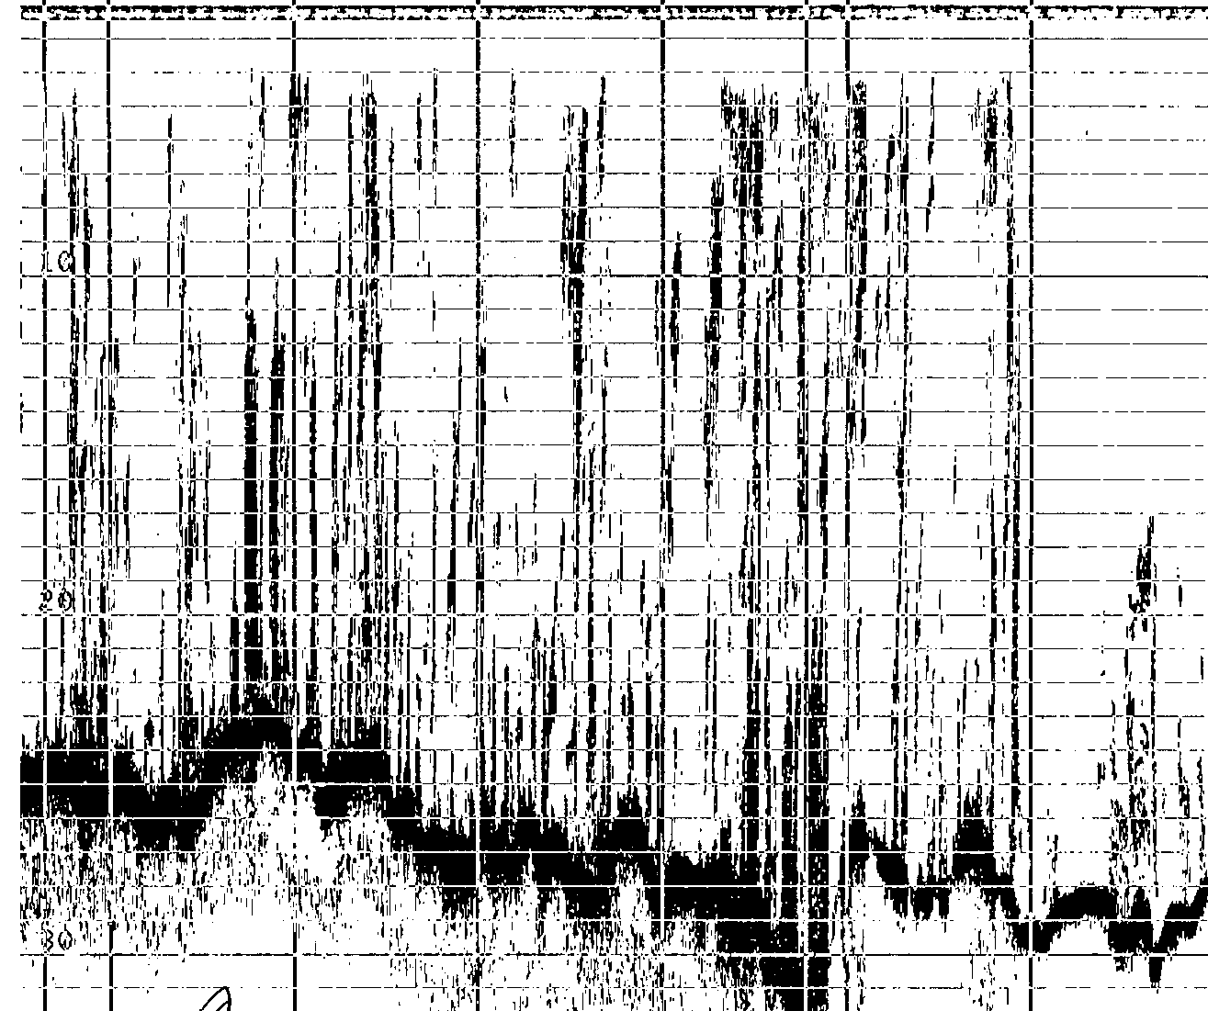

Sonar Image of Artificial Reef with Sand Waves.
960-C Grant Street, Benicia CA 94510
(707) 746-1853 info@seasurveyor.com
Side-Scan Record showing Natural Reef with Giant Kelp (Macrocystis)
Fathometer Record showing
Seafloor with Kelp in Water Column

