LAKE & RESERVOIR SURVEYS

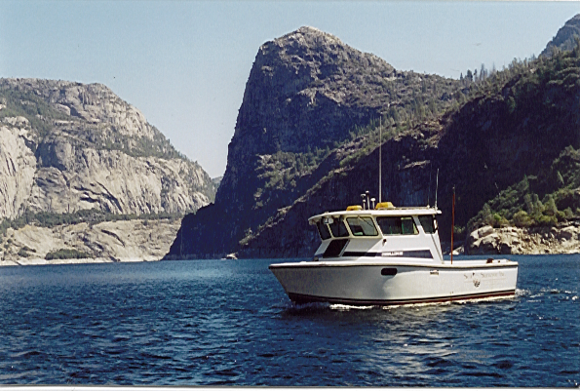
Partial List of Lakes Surveyed by SEA SURVEYOR

YEAR LAKES CLIENT COST
2006 Lake Isabella Corps of Engineers, Sacramento $ 49K

2005 Lexington Reservoir, Santa Clara Valley Water Dist. $ 35K
Uvas Reservoir, and
Chesbro Reservoir

2003 Lake Almanor Pacific Gas & Electric Co. $75K

2001 Hetch Hetchy Reservoir San Francisco Water District $16K

2000 Folsom Reservoir Bureau of Reclamation $75K

2000 Calaveras Reservoir, San Francisco Water District $22K
Lake San Antonio,
Sea Surveyor has surveyed over 50 lakes and reservoirs in 5 Western States, ranging in elevation from sea level to over 7,000’. Our tow vehicles have trailered our survey boats over 9,000’ mountain passes, and launched the boats in lakes without boat ramps. Our vessel’s have enclosed, heated cabins that allow surveys to continue in winter during rain/snow conditions.

Our 26’ survey vessel has a radiator-cooled engine, which guarantees no release of oil or gasoline into the lake. Modern sanitation systems contain all waste. Electric-powered motors propel our smaller survey boats in pristine lakes.

Hydrographic surveys are typically used to map underwater topography and compute lake capacity tables. Subbottom profiling surveys measure the thickness of sediment layers.
Lake San Andreas,
Upper & Lower Crystal
Springs Reservoir, and
Pilarcitos Reservoir

1999 Caples Lake, Silver El Dorado Irrigation District $27K
Lake, and Echo Lake

1992 Slab Creek Reservoir Sacramento Muni Utility District $17K

1992 Clifton Court Forebay Calif. Depart. of Water Resources $20K

1990 Lake Naciemiento Monterey County Flood Control $ 9K

1990 Lake Morgan, Arizona Arizona Public Service Co. $21K

1989 Bridgeport Reservoir Walker River Irrigation District $ 9K

1988 Lake Cachuma Bureau of Land Management $10K

