

**MINI-CONE CPT**

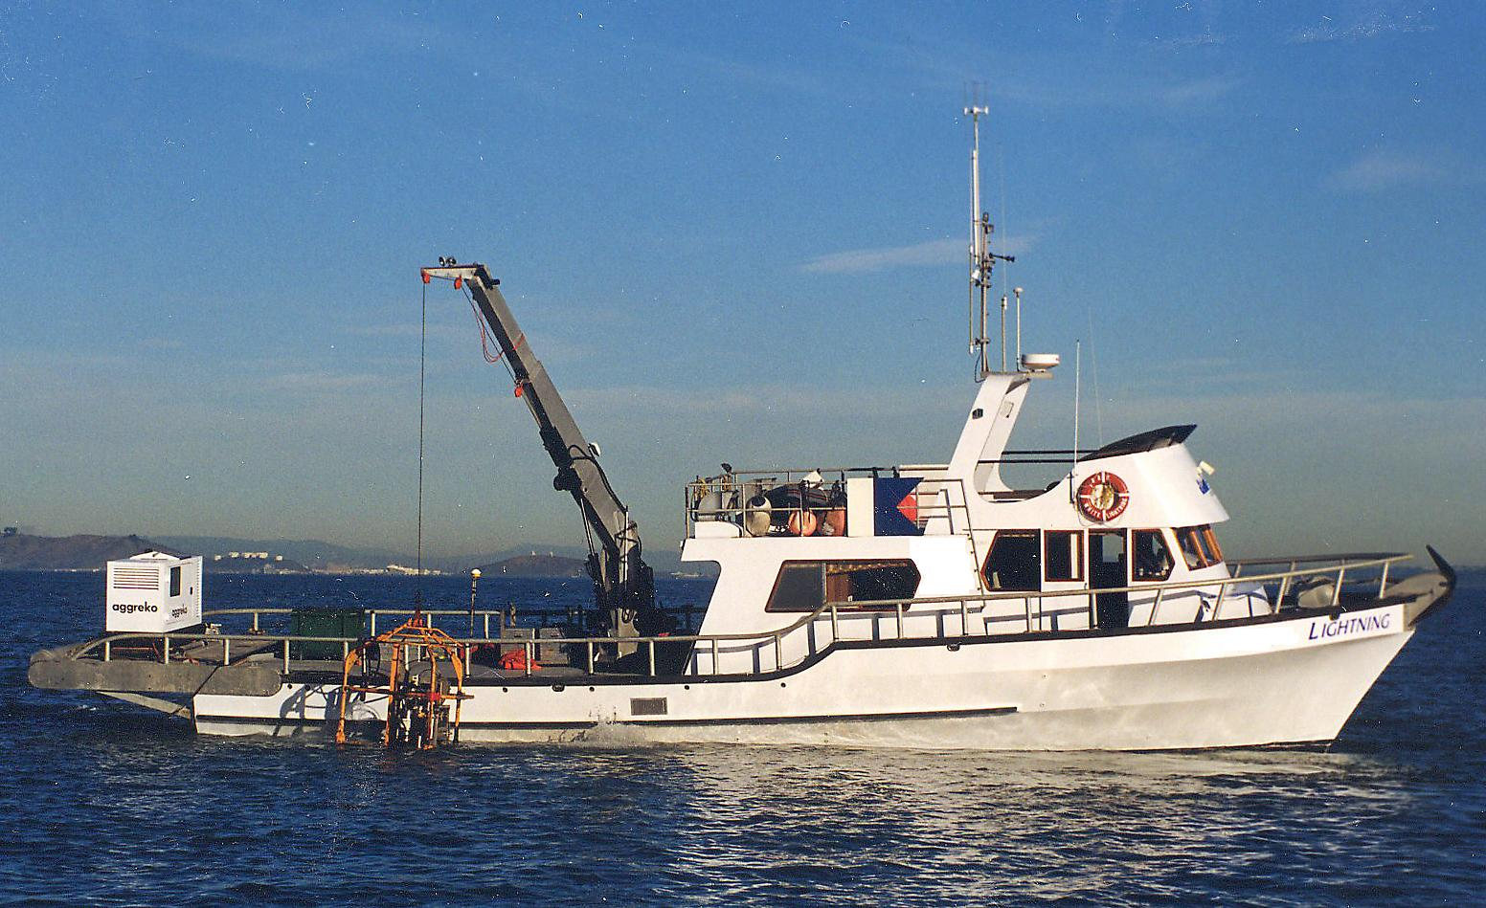

960-C Grant Street,  Benicia CA 94510

(707) 746-1853  [info@seasurveyor.com](mailto:info@seasurveyor.com)

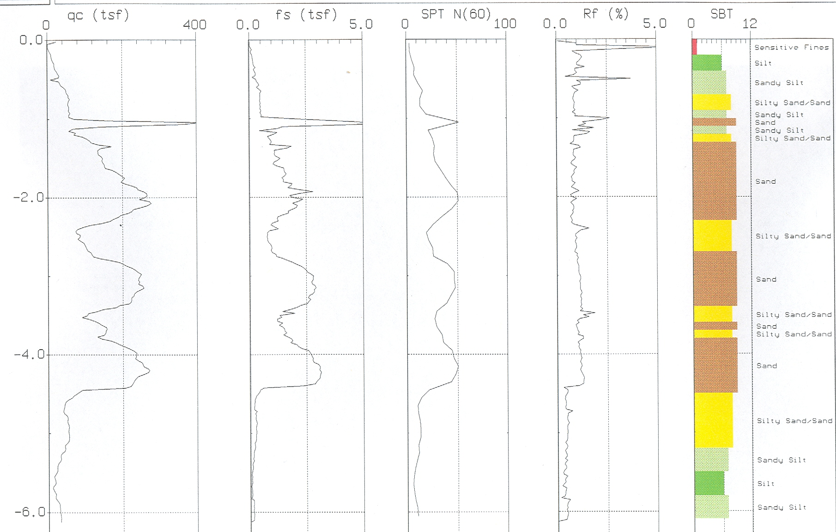

**Mini-Cone CPT on R/V *LIGHTNING* Typical Profile showing Soil Stratigraphy, Properties and Classification with Depth**

The Mini-Cone CPT is typically used with Sea Surveyor’s 6m ***ALPINE*** **Vibracore**, which collects 3.5”-diameter sediment core samples to 20-feet below the seafloor. The Mini-Cone CPT is not as stable on the seafloor or as accurate as a land-based CPT

**EXAMPLE PROJECT:** 2004 Vibracore and CPT Investigation of Offshore Sand Resources at Imperial Beach, Calif. for the *Corps of Engineers*. Contract Value: $80K

Sea Surveyor uses a lightweight Mini-Cone CPT to rapidly profile soils characteristics to a penetration depth of 6m (20-feet) below the seafloor. Enclosed within a self-righting seabed cage, the Mini-Cone CPT straightens and pushes a coiled rod into the sediments. Sensors on the rod tip determine soil stratigraphy, relative density, strength and hydrogeologic properties. Soils information is transmitted to computers aboard the support vessel via an umbilical control cable, and data is interpreted and displayed on-site using advanced software.